Midterm Results:
 | problem 1 | problem 2 | problem 3 | problem 4 | problem 5 | Midterm
Avg | 11.67 | 22.42 | 16.00 | 15.29 | 21.71 | 87.08 |  | 120+ | Fantastic
Low | 0 | 0 | 5 | 0 | 6 | 28 |  | 90-119 | Great
High | 28 | 30 | 30 | 30 | 30 | 137 |  | 70-89 | Good
Median | 11 | 22.5 | 16 | 17.5 | 24 | 83 |  | 55-69 | OK
Avg % | 38.9% | 74.7% | 53.3% | 51.0% | 72.4% | 58.1% |  | <55 | Needs work

Comments on exam: (Note: MOK → method OK, This means you did the problem correctly you just had an incorrect value from a previous part. I don’t count mistakes twice.)

Problem 1:
Part a) Series connected – you know V_{a} and I_{a} (= I_{f}) so you can find the E_{a} (need to include R_{f}, not just R_{a}, in calculation of E_{a}). You know speed so need to find K_{e} and from that K_{f} = . When current is changed to 10A, you need to find new K_{e}, new E_{a}, and thus new speed.

Part b) New K_{t} = new K_{e}. Torque is just current x K_{t}.

Part c) Shunt connected – i_{f} = . Use K_{f} from part a) to find K_{e} (= K_{f} i_{f}). Find speed from K_{e} and V_{a} (no load).

Part d) Found in part a).

Part e) Tricky! i_{f} = so i_{f} is a function of V_{a}. So K_{e} = K_{t} = K_{f} in torque vs. speed equation. You get an equation for V² so V = +/- square root of result.

Problem 2:
Part a) The only thing that tripped people up (besides algebra) was the fact that v (speed) = p x. So F_{L} = (b_{a} p + K_{a}) x.

Part b) End up with (b + b_{a}) = 1, so all terms equal 1 to make calculations easier.

Problem 3:
I put the following on the board right before the exam:
s = =

Recall that ω_{e} = ω_{em} or ω_{em} = ω_{e}

Many of you calculated the wrong value of slip. Note, in equations use ω_{e} = 377 rad/s, not 3600 rpm.

Part a)
 | 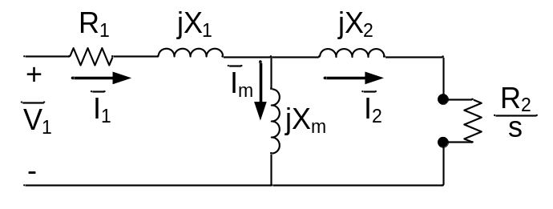 | 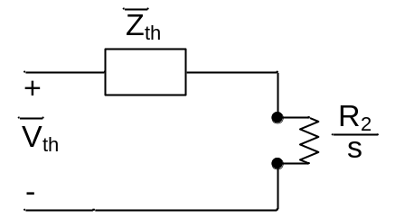
 | Thevenin Equivalent Circuit

Z_{th} = jX₂ + jX_{m} //

= |Z_{th}| solve for s_{mt}.

Part b)
Find slip. Find Z_{in}. Z_{in} ≠ Z_{th}. Find I_{s}. Find V_{m}. Find I_{r}.
T_{em} =

Part c)

P_{out} = ω_{rm} T_{em}

Part d)
P_{in} = 3 V_{φ} I_{φ} cosθ find θ from Z_{in}

η =

Part e) stretch problem – very challenging but not impossible
Find slip (negative). This gives negative R/s which just makes angle of rotor impedance more than 90º. Find Z_{in}. Z_{in}. Find I_{s}. Find V_{m}. Find I_{r}. All will have angle greater than 90º which means current is sourced (generator).
T_{em} = (slip is negative so torque will be negative)

Part f) stretch problem – very challenging but not impossible
P_{out} = 3 V_{φ} I_{φ} cosθ find θ from Z_{in} (electrical power out)

P_{in} = ω_{rm} T_{em} (mechanical power in)

η =

Problem 4:
Part a) Same as the midterm practice exam. Some of you put answer by inspection for second part of a). Make sure to state this or write out equation but don’t solve. I did not deduct points on problem 4 if you did not put L_{ls} term in self-inductance.
Part b) From trig identities provided, the integral of sinθ x cosθ (=sin2θ) over a period is zero. Makes sense because windings are orthogonal so no flux linkage between them.

Part c and d) Break integral into parts. N_{q}(θ) = - for (θ = 0 to θ_{r}),
N_{q}(θ) = + for (θ = θ_{r} to π + θ_{r}), etc.

Problem 5: (from notes)

Take home midterm: Due Nov. 10 at the start of class – You cannot work with your peers on this take home exam. You can only ask questions of Prof. Nagel. You may use a computer to check your work but you must show all work on the exam.
Homework 3: Due Nov. 17 at midnight

3φ Machine Model:

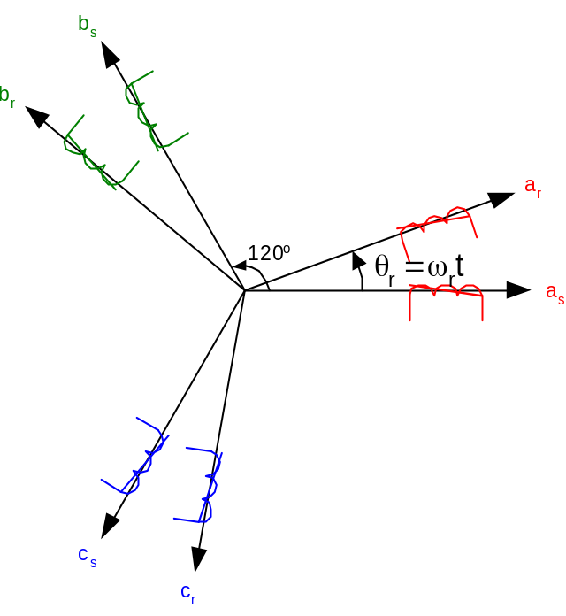
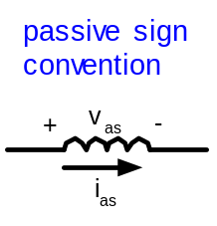
Space Vectors of a Three Phase Machine

Assume sinusoidal winding distribution
N_{a}(θ) = N_{s} cos(θ)
N_{b}(θ) = N_{s} cos(θ – 120 º)
N_{c}(θ) = N_{s} cos(θ + 120º)

Note: Do not confuse phasors with space vectors (space vectors are spatial location of winding axis, phasors are temporal (time varying) vectors)

Example: for a time based system:
i_{a}(t) = I cos(ωt)
i_{b}(t) = I cos(ωt – 120 º)
i_{c}(t) = I cos(ωt + 120º)

Phasors:  I_{a} = I ∠0 º  I_{b} = I ∠−120 º  I_{c} = I ∠120 º | 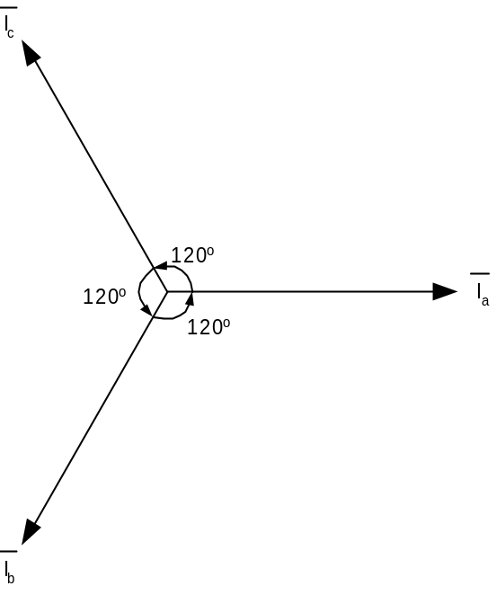
Phasor Representation of Temporal Signals

Total flux linkage for a 3φ machine in 1φ:

λ_{as} = L_{as} i_{as} + L_{abs} i_{bs} + L_{acs} i_{cs} + L_{asar} i_{ar} + L_{asbr} i_{br} + L_{ascr} i_{cr}

v_{as} = r_{s} i_{as} + p λ_{as} → voltage equation

with sinusoidal windings,

Stator Self Inductance:
L_{as} = Ns + L_{ls}

Ns = Magnetizing Inductance = L_{ms}

L_{ls} = Leakage Inductance (accounts for end turn, slot, etc.)

Stator Mutual Inductance (with other Stator Windings):
Note: Negative sign denotes flux from other winding is opposite in direction of produced by current in it’s own coil.

Stator Mutual Inductance (with Rotor Windings):
L_{asar} = N_{s} N_{r} cos → from L_{hab} = with h =1, δ = θ_{r}

Stator Voltage equation:

λ_{as} = L_{as} i_{as} + L_{abs} i_{bs} + L_{acs} i_{cs} + L_{asar} i_{ar} + L_{asbr} i_{br} + L_{ascr} i_{cr}

v_{as} = r_{s} i_{as} + p λ_{as}

= r_{s} i_{as} + L_{ls} p i_{as} + L_{ms} p +
L_{ms} p

p = cos(θ_{r}) p i_{ar} - i_{ar} sin(θ_{r})
transformer voltage
speed dependent voltage

Observations:
- These equations describe a set of nonlinear (because of product of current , position, and speed), coupled set of differential equations with time varying coefficients!
- Will show this is an 8th order (with mechanical system) nonlinear, cross coupled set of differential equations with time varying coefficients!
- Special case: = constant = ω_{r}

θ_{r} = ω_{r} t + θ_{ro}

equations are linear but still have time varying (periodic) coefficients

------------------------------------------ ----------------------------------------

System Equations for a 3φ Machine in the Stationary a,b,c Reference Frame:
time rate of change of flux

V_{abcs} = r_{s} I_{abcs} + p L_{abcs} stator equation

V_{abcr} = r_{r} I_{abcr} + p L_{abcr} rotor equation

V_{abcs} = I_{abcs} = L_{abcs} =

but there is coupling between the stator and rotor so we can separate the flux linkage into 2 matrices:
stator quantities
rotor quantities referred to stator

L_{abcs} = L_{abcs(s)} + L_{abcs(r)}

L_{abcr} = L_{abcr(s)} + L_{abcr(r)}

L_{abcs(s)} = I_{abcs} L_{abcs(r)} = I_{abcr}

L_{abcr(s)} = I_{abcs} L_{abcr(r)} = I_{abcr}

Flux Linkages of stator phase windings resulting from currents flowing in the stator windings:
because of cos(120º) of windings
L_{as} = L_{ms} + L_{ls} = L_{bs} = L_{cs} L_{abs} = L_{acs} = L_{bcs} = L_{ms}

L_{abcs(s)} = I_{abcs}

Flux Linkages of stator phase windings resulting from currents flowing in the rotor windings:

L_{asar} = L_{bsbr} = L_{cscr} = L_{ms} cos(θ_{r})

L_{asbr} = L_{bscr} = L_{csar} = L_{ms} cos(θ_{r} + 120º)

L_{ascr} = L_{bsar} = L_{csbr} = L_{ms} cos(θ_{r} - 120º)

L_{abcs(r)} = L_{ms} I_{abcr}

For rotor flux linkages due to stator and rotor currents:

L_{abcr(r)} = I_{abcr}

L_{abcr(s)} = L_{ms} I_{abcs}

v_{as} = r_{s} i_{as} (L_{ms} + L_{ls}) p i_{as} - p (i_{bs} + i_{cs}) +
L_{ms} p

{6 equations of this form}

Complex Vector Notation

e^{jθ} = cos(θ) + j sin(θ) Euler Identity

e^{-jθ} = cos(θ) - j sin(θ)

cos(θ) =

common notation: Let a = e^{+j120o} = -0.5 + j

a² = e^{+j240o} = -0.5 – j

a³ = e^{+j360o} = 1 + 0 j

1 + a + a² = 0

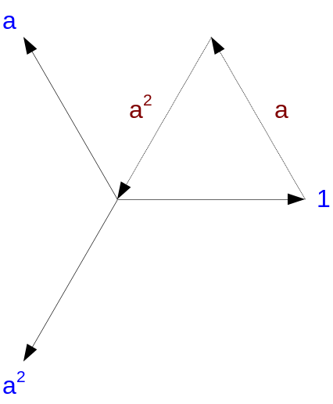

Define Complex Vector Voltage:
v_{abcs} = v_{as} + a v_{bs} + a² v_{cs} Space Vector

Define Complex Vector Current:
i_{abcs} = i_{as} + a i_{bs} + a² i_{cs}

3φ Machine:
v_{abcs} = v_{as} + a v_{bs} + a² v_{cs} i_{abcs} = i_{as} + a i_{bs} + a² i_{cs}

1) Stator Resistive Terms
i_{as} r_{s} + a i_{bs} r_{s} + a² i_{cs} r_{s} =

2) Stator Self Inductance Terms
(L_{ms} + L_{ls}) p (i_{as} + a i_{bs} + a² i_{cs}) =

3) Mutual Terms (Stator)

L_{ms} p =

L_{ms} p =
-a²
-1
-a

L_{ms} p =

4) Mutual Terms (Rotor)

L_{ms} p

= L_{ms} p

= p
0
= p

=

Stator Voltage Equation:

v_{abcs} = r_{s} i_{abcs} + +

L_{s}

Apply Turns Ratio

i = i _{abcr} r = ²r_{r} L_{m} = L_{ms}

v = v _{abcr} L = ²L_{mr} + L

The final complex vector equations with turns ratio transformations:

v_{abcs} = r_{s} i_{abcs} + L_{s} p i_{abcs} + L_{m} p

v = r i + L p i + L_{m} p

Transformations to a Rotating Reference Frame:

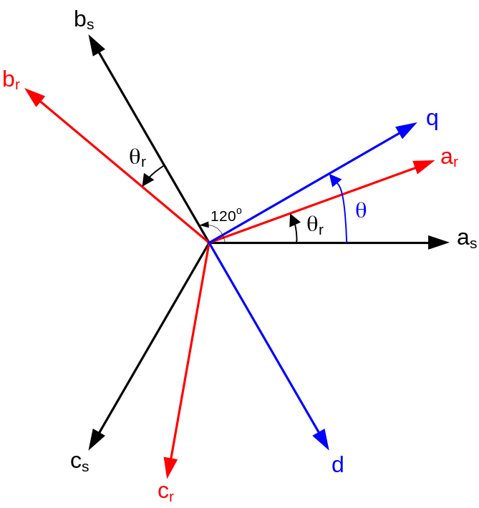
General Reference Frame of a Three Phase Machine

f_{qs} =

f_{ds} =

f denotes v, i, or λ

Note: Scale factor is used to preserve magnitude relationship for sinusoidal steady state quantities. Another common choice is to preserve power calculations between abc & dq coordinates.

Third variable is necessary to define a unique transformation (since there are three variables):

f_{0s} = zero sequence component (normal to dq plane)

Note: Under most conditions, f_{0s} = 0 (but not always!).

Define New Complex Vector:
f_{qds} = f_{qs} – j f_{ds} =
= e ^{- jθ}

The a operator handles transformation from 3φ to 2φ and the e ^{- jθ} handles the rotation.

f_{qdr} = e ^{- j(θ - θr)}

Recall Complex Variable form for stator given by:

v_{abcs} = r_{s} i_{abcs} + L_{s} p i_{abcs} + L_{m} p

multiply by e ^{- jθ} →
e ^{- jθ} v_{abcs} = r_{s} e ^{- jθ} i_{abcs} + L_{s} e ^{- jθ} p i_{abcs} + L_{m} e ^{- jθ} p

From the chain rule of differentiation:

x = (x y) - y from (x y) = x + y

Therefore:
e ^{- jθ} v_{abcs} = r_{s} e ^{- jθ} i_{abcs} + L_{s} p(e ^{- jθ} i_{abcs}) + L_{m} p +
j ω

-y

v_{qds} = r_{s} i_{qds} + L_{s} p i_{qds} + L_{m} p i + j ω

for Rotor:
v = r i + L p i + L_{m} p i_{qds} + j(ω - ω_{r})

For zero sequence:

v_{as} + v_{bs} + v_{cs} = (r_{s} + p L_{ls}) (i_{as} + i_{bs} + i_{cs})

v_{0s} = (r_{s} + p L_{ls}) i_{0s}

v = (r + p L) i

Summary of Equations (Can Implement in Simulations):

For Stator:
v_{qs} = r_{s} i_{qs} + + ω λ_{ds}

v_{ds} = r_{s} i_{ds} + - ω λ_{qs}

v_{0s} = r_{s} i_{0s} +

where
λ_{qs} = L_{ls} i_{qs} + L_{m} (i_{qs} + i)

λ_{ds} = L_{ls} i_{ds} + L_{m} (i_{ds} + i)

λ_{0s} = L_{ls} i_{0s}

For Rotor:
v = r i + + (ω - ω_{r}) λ

v = r i + - (ω - ω_{r}) λ

v = r i +

where
λ = L i + L_{m} (i_{qs} + i)

λ = L i + L_{m} (i_{ds} + i)

λ = L i

As stated, in most cases machine is connected in Δ or Y such that no neutral current flows. In this case, v_{0s} & v equal zero. The four remaining equations are often assembled in matrix form as:

=

where L_{s} = L_{ls} + L_{m} L = L + L_{m} L_{m} = L_{ms}

Three Phase Machine dq0 equivalent circuit:

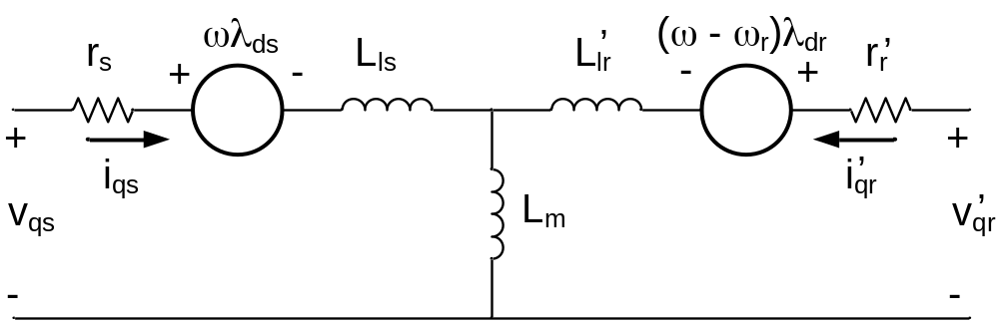
q – Axis Equivalent Circuit
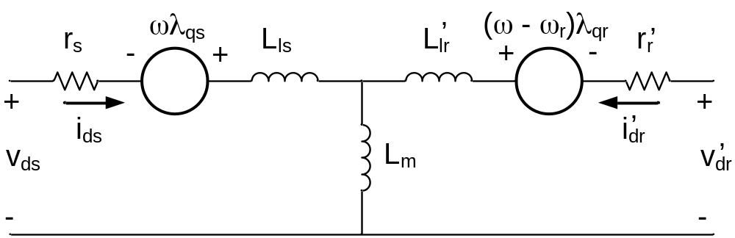
d – Axis Equivalent Circuit
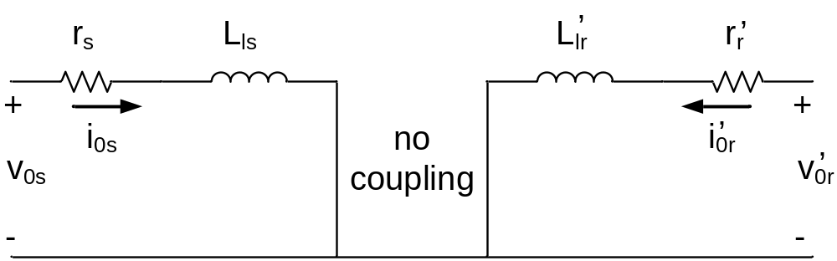
0 – Axis Equivalent Circuit

Note: zero sequence components undesirable in machines because they can only produce heat, not torque.

Formalize and simplify notation:

f f is a variable (v,i,λ)
x is where the variable comes from (r,s)
(actual location of variables)
y is where variables are referred to (r,s,g)

Stator Refered Complex Variable Equations (θ,ω = 0):
(Note: Now dropping ’ notation, it is assumed)
v = r_{s} i + L_{s} p i + L_{m} p i

v = r_{r} i + L_{r} p i + L_{m} p i - jω_{r} (L_{r} i + L_{m} p i)
= r_{r} i + L_{r} (p - jω_{r}) i + L_{m} (p - jω_{r}) i

which can be re-written as:
v = r_{s} i + p l

v = r_{r} i + (p - jω_{r}) l

where
l = L_{s} i + L_{m} i

l = L_{r} i + L_{m} i

=

Rotation to a General Reference Frame

f = fcosθ + f sinθ  f = fcosθ - f sinθ | 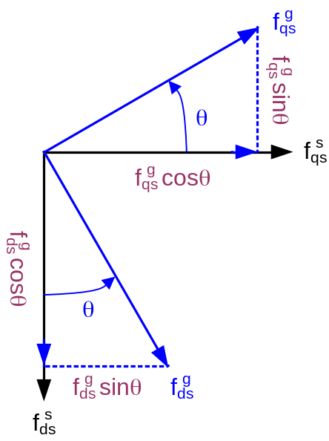

f = f – j f

= f cosθ + f sinθ – j f cosθ + j f sinθ

= f (cosθ + j sinθ) + f (sinθ – j cosθ)

= f (cosθ + j sinθ) – j f (cosθ + j sinθ)

= (f – j f) (cosθ + j sinθ)

→

